**Stream Visual Assessment Protocol (SVAP)**

Southern Indiana Stormwater Advisory Committee

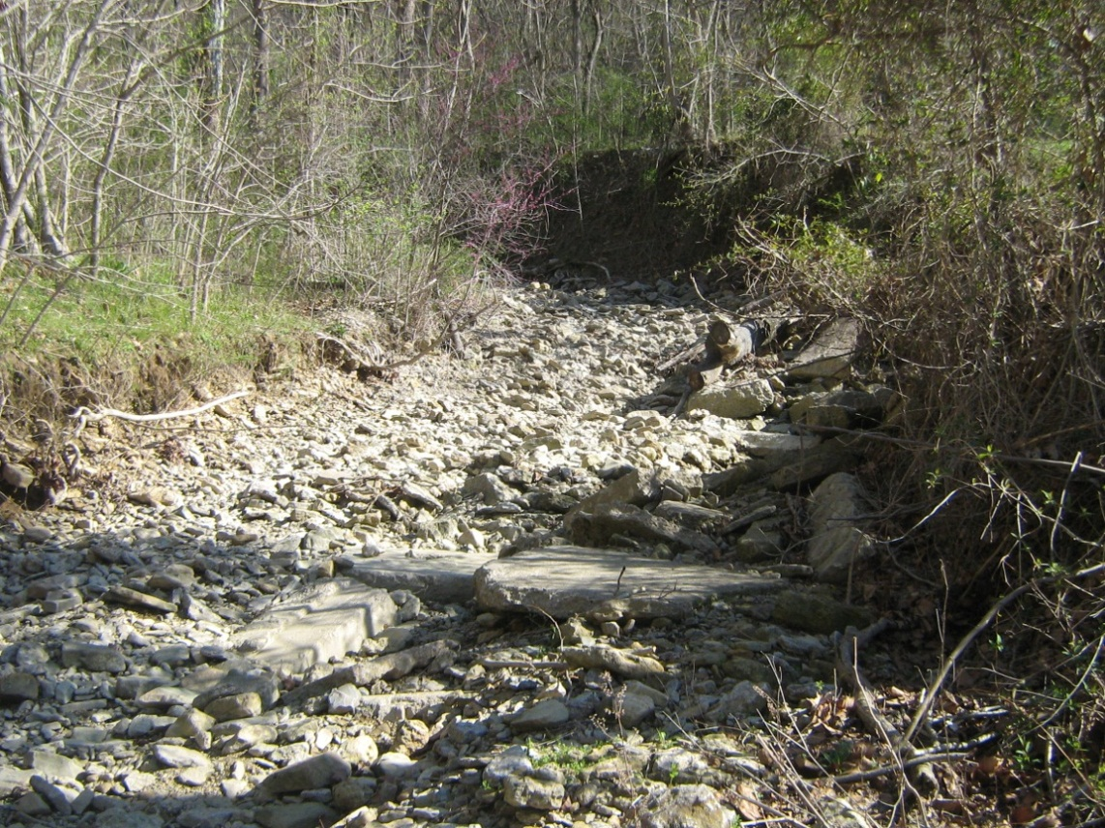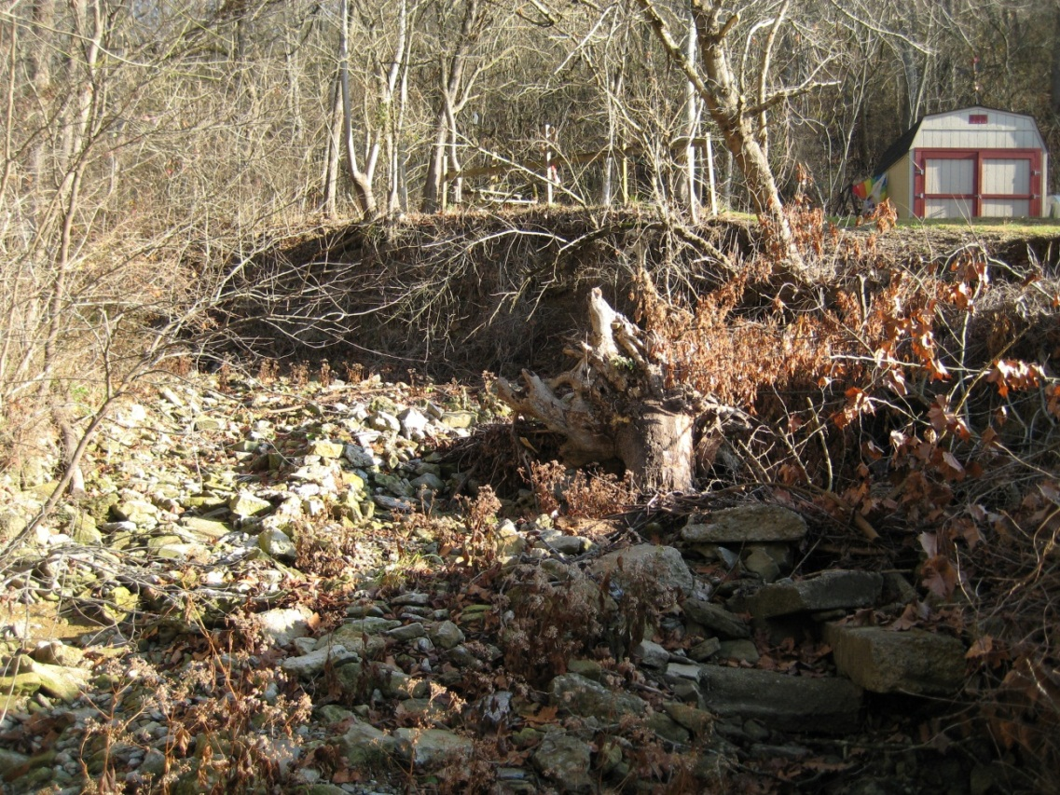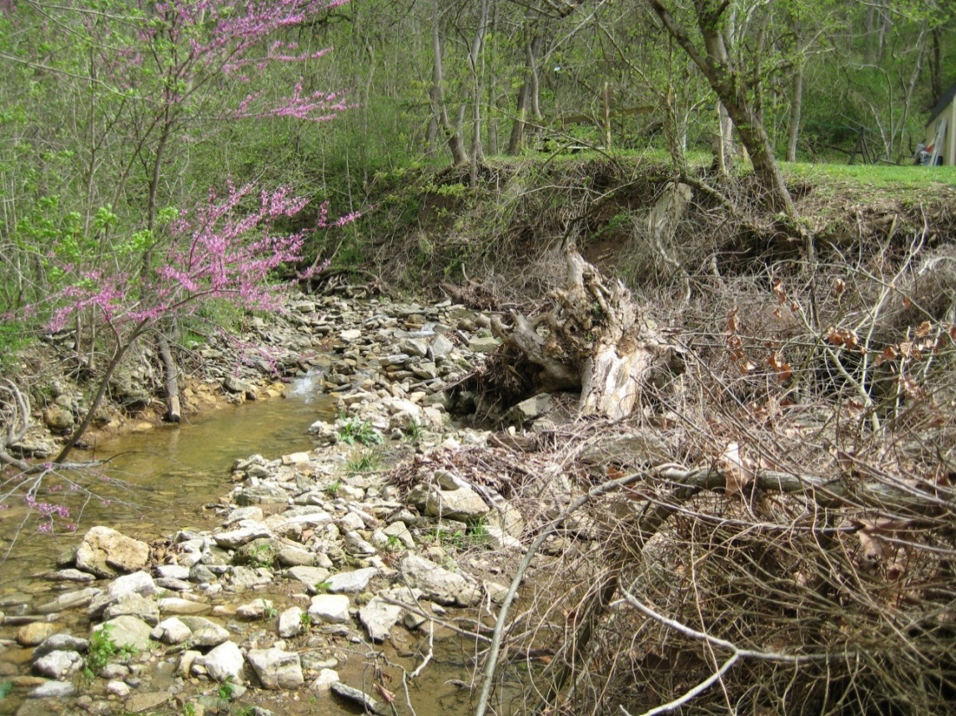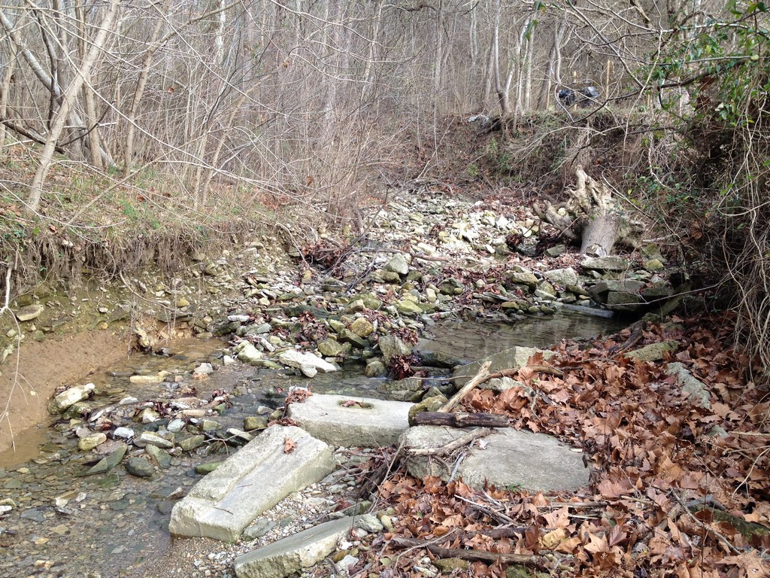

Developed: February 2009

Reproduced: May 2022

Table of Contents

1.0 Purpose 1

2.0 Stream Visual Assessment Protocol Overview 2

3.0 Site Selection 2

4.0 Initial Screening 3

5.0 Data Entry and Management 5

6.0 Identifying, Prioritizing and Implementing Solutions 6

6.1 identifying potential issues 6

6.2 prioritizing identified issues 9

6.3 Implementing solutions 11

7.0 Additional Screening and Next Steps 13

8.0 References 14

**Appendices**

Stream Visual Assessment Protocol Field Collection Form

**Table of Revisions**

The following table summarizes revisions, additions, deletions, etc. to the Stream Visual Assessment Protocol:

| **Date** | Affected Sections | **Summary of Change** |
| --- | --- | --- |
| 7/5/19 | Cover, 1st page, Header, and Section 5.0 | Various minor updates to content. |
| 05/3/2022 | Cover, Header, and Section 1.0 | Updated information to reflect new permit. |
|  |  |  |
|  |  |  |
|  |  |  |
|  |  |  |
|  |  |  |
|  |  |  |
|  |  |  |
|  |  |  |
|  |  |  |

# Purpose

The Indiana MS4 General Permit INR040000 requires characterization of water quality within the MS4 service area in Section 3: Water Quality Characterization Report. INR040000, requires the information to “describe the chemical, biological, or physical condition of the MS4 area water.” Additionally, MS4 entities are required to provide updates to this information through the On-Going Water Quality Characterization section of the MS4 program reports. The MS4 program reports require regulated communities to report on follow-up or additional water quality characterization and updated receiving water information. The goal of these assessments is to provide planning tools and data to: 1) Evaluate the health of receiving waters in the MS4 area, 2) Assess the impact of MS4 discharges to waters of the state, and 3) Identify impacted receiving waters that may benefit from watershed enhancements, both structural and non-structural best management practices (BMPs).

In order to gain a better understanding of how the MS4 impacts the overall quality of nearby surface waters, the Stream Visual Assessment Protocol (SVAP) is being implemented during Permit Term Two. The SVAP is designed to provide an efficient and economical solution for On-Going Water Quality Characterization Activities required in the Storm Water Quality Management Plan (SWQMP) permit. Data gathered from the SVAP allow the community to identify locations that could potentially benefit from maintenance or remediation activities, protection measures and to identify strategies for improving water quality throughout the community. Results can be used to prioritize more detailed investigations and to target improvement and protection activities to achieve the greatest benefit for the resources expended.

This protocol was developed through the cooperative efforts of the Southern Indiana Stormwater Advisory Committee (SWAC), which consists of MS4 entities in southern Indiana, including the City of Jeffersonville, the City of New Albany, the City of Madison, the Town of Clarksville, the Town of Sellersburg, the Oak Park Conservancy District (OPCD) and Floyd County. The SWAC was formed in 2004 to assist with program consistency and minimize duplication of efforts among neighboring MS4 jurisdictions. The SWAC has guided the development and implementation of each MS4’s SWQMP. SWAC membership consists of MS4 Coordinators, members of various local constituencies, including members of the public and the construction/development community, as well as local Health Departments and Soil and Water Conservation Districts. The SWAC is a platform for receiving and discussing public input and developing activities to address issues critical to each community’s SWQMP. This SVAP represents a continuation of a multi-year history of cooperation among southern Indiana MS4 communities.

# Stream Visual Assessment Protocol Overview

This Stream Visual Assessment Protocol is an extension of the *Illicit Discharge Detection and Elimination Standard Operating Procedure and Guidance* developed by the SWAC and implemented in southern Indiana MS4 communities. Existing stream assessment methods developed by the Center for Watershed Protection, the US Environmental Protection Agency and the US Department of Agriculture were reviewed. This Protocol incorporates relevant aspects of these assessment procedures, streamlined to provide assessment data and information relevant to stormwater management in southern Indiana.

The Stream Visual Assessment Protocol consists of the steps outlined below. The remaining sections of this manual discuss each step in more detail.

* Site selection
* Initial screening
* Data management and analysis
* Identify potential solutions
* Prioritize potential solutions
* Implement selected solutions
* Additional screening

# Site Selection

Maps and GIS data of the MS4 area are used for site selection. Recommended SVAP sites were selected using the following site selection criteria:

* Select at least one (1) site per HUC14 subwatershed in watersheds with accessible stream drainage (start at the bottom of a watershed and proceed upstream)
* Consider existing monitoring sites for SVAP sites
* Select sites near parks and public access areas
* Select sites near sensitive areas identified in Part B: Baseline Characterization, including wellhead protection areas, wetlands, Outstanding or Exceptional Resource Waters, sinkhole areas
* Select sites draining urban areas with MS4 outfalls
* Use aerial photography of the area to visually screen for geomorphology such as channel straightening, low dams, low water crossings, moving streams for road construction, etc. Select sites near these features
* Select sites draining representative land use types
* Select sites near known problem areas and impaired streams
* Coordinate the selection of sites near MS4 boundaries with adjacent communities to provide the data to support future watershed-based assessments.

Sites were selected at bridge crossings that meet as many of these criteria as possible. SWAC communities reviewed the list of sites before the screening began and have the option to assess additional sites in new areas if concern develop. The number of sites assessed varies according to the size of the MS4 area, number of stream miles and additional assessments conducted to investigate problem areas identified in the initial screening. The SVAP can be used to investigate and respond to citizen inquiries and complaints received via stormwater hotlines or other avenues.

The SVAP site maps produced for this effort show site locations for each community, and adjacent MS4 communities. This approach was used to facilitate data sharing and provide the information needed for watershed-based assessments.

# Initial Screening

Screening takes place from the bridge crossings looking upstream. Ideally, the screening takes place twice per year, in the spring before leaf on and in the fall after leaf off. Field information is filled out using a paper form. An identical form can also be completed using a handheld global positioning system (GPS) unit, such as a Trimble GeoXT, if available. The Field Collection Form is provided as **Appendix 1.**

The information on the field form is intended to be collected visually from the bridge and require about 15 minutes per site. Very basic field equipment is needed: a stop watch or watch with a second hand, a 25’ or 50’ tape measure with a plumb-bob or weight and a digital camera.

The following section provides further explanation of the type of information collected on the field form. Visual references are included in **Appendix 2**.

**Site Information:** Site ID numbers are composed of a 3-digit community code, abbreviated watershed name and a 3-digit number. See section 7.0 for further details concerning site ID numbers. The sites are depicted on a corresponding map, provided as **Appendix 3**,and listed in a table with additional information, provided as **Appendix 4**.By completing information regarding the date and time of data collection, names of those on the field crew, it will be easier to address any questions that arise later.

**Current Conditions:** Complete the information regarding recent weather conditions. Use the stop watch or watch with a second hand to measure approximate water velocity by timing a floating object (stick, leaf, etc.) over an estimated distance of 10 feet. (Example: if the object went an estimated 10 feet in 5 seconds, then 10 ft / 5 sec = 2 ft/sec). Measure the distance of the bridge rail to the water surface and the depth of the water using a plumb bob tape or tape measure with a weight.

**Visual Water Quality Assessment:** Assess the general water quality of the stream including water color, odor, clarity, floatables, algae and presence of stagnant water.

**High Water Mark:** High water marks can provide an indication of relative risk of flooding and be observed as debris deposits or stains on trees. The height of the high water mark should be estimated relative to the bridge railing or other permanent structure. Circle ABOVE or BELOW on the Field Collection Form to indicate the position of the high water mark relative to the bridge railing or other permanent structure.

**Erosion:** Stream erosion occurs when the volume and velocity of water wears away the banks and bed of a waterway. This type of erosion can threaten the stability of infrastructure located near the waterway, including bridges, culverts, roads, sewer lines etc. and can be devastating for plant and animal life downstream.

Estimate the height of left and right banks relative to the stream bed (if possible) or the water surface if the stream bed is not visible. Estimate the percent of each bank that is vegetated and the major or dominant type of vegetation present. If erosion is present, circle YES or NO to indicate whether there is an obvious cause. If possible, describe all obvious causes of erosion which include inadequate riparian vegetation, scour from discharge pipes, or scour from increased water velocity potentially caused by downstream straightening or channelization.

**Sedimentation:** Sedimentation occurs when suspended particles settle to the bottom of a stream or pond. Excessive sedimentation may occur when materials from upstream eroded areas settle. Sedimentation typically results in the formation of islands and point bars. Excessive sedimentation can reduce water conveyance under a bridge, potentially contributing to flooding, reduce storage volume in detention or retention ponds as well as reservoirs, increase filtration costs for water supplies and cause or contribute to fish kills.

Note the presence of sediment islands and/or point bars. Record the maximum sediment size of these deposits as “smaller-------pea-------baseball-------basketball-------larger” These sizes correspond to sediment types: Sand, silt and clay refers to rock, mineral or soil particles smaller than a pea. Gravel refers to rocks bigger than a pea and smaller than a baseball. Cobble refers to rocks bigger than a baseball and smaller than a basketball, and boulders refer to rocks larger than a basketball.

**Debris/Obstructions/Scour:** Describe the structure as a bridge, culvert or other structure and provide its dimensions in feet. Describe the degree and type of obstruction occurring at this structure, if any. If visible, note whether there are scour issues around the bridge abutments or piers, or around culvert headwalls

**Visible Outfalls:** Assess left and right banks for outfalls. Describe the pipe material and diameter. Describe pipe discharge if present. Failing septic systems are often difficult to detect. Common signs of failing septic systems include the presence of sewage odors, water ponding in yards, and areas of excessive vegetation. In the description, note if the outfall is known or suspected of being an MS4 outfall, and document other relevant information.

**Evidence of Livestock Access to Stream:** For sites in pasture areas, note whether livestock exclusion fences are present and functioning, whether livestock are present in the stream, or whether there are indicators of livestock access, such as tracks and manure. Estimate the type and numbers of livestock with stream access.

**Litter/Trash:** If litter or trash is present in the stream, describe the type by circling all that apply, and the quantity. Include additional notes as needed.

**Other Information:** Note the presence and size of beaver dams, opportunities for new BMPs or BMP retrofits, and visible land uses and descriptions. If a construction site is present, note whether construction site BMPs are being appropriately implemented.

**Photo Log:** Record photo number and descriptions of all pictures taken at the site. Photos at each site should include a general picture of the site, the current water level, potential illicit discharges (discolored water, oil sheen, etc.), the high water mark (include the bridge rail or reference point in the photo if possible), areas experiencing active erosion and/or sedimentation, any obstructions or log jams present, any outfalls present, beaver dams present, and litter or trash present.

# Data Entry and Management

Data collected in the field using a handheld GPS unit or similar electronic device increases the speed and accuracy of data collection. Once collected, the data are exported from the device to a computer in the form of a database (.dbf) file. This .dbf file can be saved as a spreadsheet file, which allows for further processing and analysis of the data in a spreadsheet program such as Microsoft Excel.

Data collected in the field using a paper form are entered manually into a spreadsheet file, which is similar to the file generated when collecting data with a handheld electronic device. This allows all data to be managed, processed and analyzed in the same manner regardless of the collection method.

SVAP photos are downloaded off the camera onto a computer and labeled according to the photo log. All photos for a given date are stored in a folder with the SVAP date, with subfolders for each site containing the pictures from that site. Within the spreadsheet file containing the SVAP data, each site will have a hyperlink that will link to the folder containing SVAP photos for that site.

Once the data and photos are entered, each site is evaluated for potential issues. Reference the site map during the evaluation to help draw conclusions from each site’s data based on its location. SVAP data can also be linked to SVAP sampling points using ESRI’s ArcGIS software, allowing for a spatial analysis of the data. Site pictures should also be referenced when identifying issues related to stormwater.

Some issues identified through the SVAP monitoring may be occurring on a watershed scale or near the boundary with an adjacent community. The maps produced for the SVAP show monitoring sites in each community and adjacent communities. Communities may elect to work collaboratively to share and assess data.

# Identifying, Prioritizing and Implementing Solutions

## identifying potential issues

Data collected during the SVAP can be used to identify potential issues affecting the streams in the MS4 area. The data collected during the SVAP screening process are designed to allow the community to identify a wide range of water quality issues, including potential illicit discharges, flooding conditions, erosion or sedimentation problems, upstream land management practices and illegal dumping. Additionally, good quality streams that may benefit from protection measures may also be identified. An description of how each category of SVAP data can be used to identify potential water quality issues is provided below.

**Visual Water Quality Assessment:** The visual water quality assessment may indicate a variety of potential water quality issues. Indicators of nutrient enrichment include excessive floating or rooted algae, green or brown water, often slow moving or stagnant. Potential sources of nutrients may include runoff from farms, golf courses, stormwater discharges containing lawn chemicals, failing or inadequate septic systems and eroded soils. Leaking sewer lines and sanitary sewer overflows that contribute nutrients could also be occurring. These are indicated by visible signs of sewage, sewage smell or rotten egg smell.

If dry weather flows are observed from an MS4 outfall, the *Illicit Discharge Detection and Elimination (IDDE) Standard Operating Procedure and Guidance* should be used to investigate and eliminate the illicit discharge. An excerpt from this document is included in **Appendix 5**.

**High Water Marks:** The height of a high water mark relative to a bridge or culvert provides an indication of the potential for flooding. If the high water mark is above the bridge or culvert or within close proximity to the underside of the bridge or culvert, the area may be at risk for flooding. By comparing high water marks from a single storm at all sites, the potential for flooding can be identified and prioritized within the community.

**Erosion and Sedimentation:** Erosion is a concern because severely eroding stream banks can threaten the stability of bridges, culverts and roads as well as affecting private property and businesses. As stream banks erode, sediment is deposited downstream, potentially affecting water quality and stream habitat. Sediment deposits can reduce stormwater conveyance of bridges, culverts and channels and can contribute to localized flooding and further erosion. Sediment deposits at SVAP sites indicate that erosion is occurring upstream of the assessed site. The size of the largest sediment particles is an indicator of the power of the stream to move sediment.

Sediment deposits are typically seen as sediment islands that form above bridges and culverts and point bars that occur on the inside of a bend in the stream. The severity of sedimentation at SVAP sites can be prioritized by the size of the deposit and the size of the material deposited. Larger sediment deposits and larger sediment materials are generally an indication of a more significant in-stream sedimentation issue.

Sediment can originate from various sources both inside and outside of the stream. As runoff flows over land, it can pick up sediment, which, if unchecked, will be released in streams and waterbodies. This issue is relatively minimal in areas with adequate vegetation, particularly along stream corridors (i.e., riparian vegetation). In watersheds with steep slopes, erodible soils and inadequate riparian vegetation, many tons of sediment can be released each year.

In-stream erosion of stream banks and stream beds (i.e., downcutting) are very common forms of erosion. Changes in the timing and increase in the volume of runoff that occur when impervious areas increase can contribute to in-stream erosion. This issue may be magnified in areas with steep slopes, erodible soils and inadequate riparian vegetation. In some cases, a stormwater outfall configuration may contribute to erosion via scour around the outfall and/ or on the opposite bank.

Factors such as vehicle crossings, livestock access, inadequate BMPs at construction sites may also contribute to erosion and sedimentation.

**Debris, Obstructions and Scour:** As discussed above, sediment deposits upstream and downstream of bridges and culverts can constrict and reduce drainage conveyance, which can contribute to localized flooding and water quality problems.

Scour issues can be prioritized for additional investigation using presence/absence data and any initial information regarding the severity of the scour issues identified via SVAP screening.

**Visible Outfalls:** If the outfall is known or suspected of being an MS4 outfall, check the location in the MS4 mapping database. If the outfall is not included in the database, map the outfall and conveyance as a part of the ongoing efforts to maintain and update the MS4 map and database. If the SVAP data indicate that the MS4 outfall is compromised by erosion around the outfall, or it is contributing to scour on the opposite bank or in-stream, it should be considered for further action based on the size of the outfall, severity of the erosion or scour problem and the type of stream affected.

If the outfall is known or suspected of being a sanitary sewer overflow and flow was present, notify the appropriate personnel immediately. Sanitary sewer overflows can contribute to elevated bacteria and human pathogens in streams, increasing the risk of illness associated with stream contact. Therefore, known or suspected sanitary sewer overflows are considered to be a high priority issue.

Failing septic systems can contribute to elevated bacteria and human pathogens in streams, increasing the risk of illness associated with stream contact. Therefore, known or suspected failing septic systems are considered to be a high priority issue.

Many MS4 communities have generated a standard operating procedure (SOP) for detecting and eliminating illicit discharges, which can be utilized and referenced during the SVAP screening process. Each community is also required to implement an ordinance concerning illicit discharge detection and elimination, which may be helpful during the SVAP screening process.

**Livestock Access to Streams:** Allowing livestock to access creeks for water supply and creek crossings is a common agricultural practice. Concerns with this practice include erosion, nutrient and bacteria pollution. The Natural Resource Conservation Service (NRCS) can provide farmers with cost share funds to install livestock crossings, exclusion fences and alternate water supplies.

**Litter / Trash:** The presence of large amounts of litter or trash in streams may be evidence of illegal dumping. Known or suspected illegal dumping as well as litter and trash in high visibility locations such as parks should be considered a priority. If a location with significant litter or trash is downstream of MS4 outfalls, additional investigation may be warranted to determine if the MS4 is contributing to the pollution, and if so, litter clean-up, street sweeping and other BMPs may be needed to address this issue.

**Beaver Dams:** Beaver dams that obstruct a significant portion of the stream channel can cause upstream drainage issues. Under high flow conditions, beaver dams can fail suddenly. If a large volume of water is being stored behind the dam, downstream flooding can occur. Beavers can damage or destroy riparian vegetation, particularly willows and sycamore trees as they build their dams. The ponds behind beaver dams may function as mosquito breeding habitat, a concern for West Nile virus.

Beaver dams with a significant potential to cause flooding that would affect public infrastructure (e.g., roads, bridges) or private property can be considered for removal. Beaver ponds that may serve as a breeding location for mosquitoes, and thus a risk for West Nile virus, can be referred to appropriate public health officials.

## prioritizing identified issues

After potential issues have been identified, it is important to prioritize solutions in order to maximize its efforts and the effectiveness of the improvements. Several prioritization approaches may be considered. For example, the most pressing or urgent issues may be given highest priority. This approach may be particularly effective to address relatively few significant issues. Issues that can be addressed with minimal effort, through partnerships with local entities and agencies (e.g., NRCS) may be given priority. Some additional considerations for priorities are provided below.

**Public Health:** Assigning a high priority to issues that present a significant public health concern may be warranted. Potential public health issues that may be identified through the SVAP assessments include discharges from sanitary sewer overflows, known or suspected failing septic systems, risk of West Nile virus associated with mosquito breeding locations.

**Public Safety:** Assigning a high to medium priority to issues that may affect public safety may be warranted. Potential public safety issues that may be identified through the SVAP assessments include erosion and/or scour that damages or threatens bridges, culverts or roadways and flooding related issues.

**Funding Availability:** Issues for which funding is available may be given priority. For example, grants from the Federal Emergency Management Agency (FEMA) to address flooding issues may be available. NRCS cost share programs could be used to minimize the impacts of livestock access to creeks and streambank stabilization. Nonpoint source grants, available from the Indiana Department of Environmental Management (IDEM) may be used to develop watershed plans that assess water quality issues on a watershed basis and develop implementation strategies that reflect community priorities to address issues.

**Watershed Issues:** Some issues identified through the SVAP monitoring may be occurring on a watershed scale or near the boundary with an adjacent community. Communities may elect to work collaboratively to identify and prioritize concerns that transcend MS4 boundaries. This collaborative approach may facilitate implementing cost-effective and timely solutions as well as improve opportunities for grant awards.

**Sensitive Areas:** Assigning a medium priority to issues that may affect sensitive areas may be warranted. Sensitive areas may include public beaches or areas used for swimming, boat launches, sinkhole areas, wellhead protection areas, wetlands, and designated Outstanding or Exceptional Resource Waters. Potential issues affecting water quality in sensitive areas that may be identified through SVAP implementation include erosion and sedimentation as well as pollution from known or suspected sources such as sanitary sewer overflows, failing septic systems, illicit discharges to the MS4, construction sites with compliance issues, and livestock access to streams. Additionally flooding, particularly flooding associated with human-induced changes in hydrology and stream characteristics, may also negatively impact habitats in sensitive areas.

**Complexity Considerations:** For the issues identified above, the level of complexity is also likely to influence the priority and scheduling of efforts to address the issue. For example, pressing erosion and sedimentation issues may be addressed using solutions such as stabilizing banks or removing accumulated sediment from bridges, culverts or other conveyances. This approach addresses the immediate concern and provides time for the community to monitor the situation over time. If the problem is chronic and requires frequent, repeated maintenance, a more comprehensive solution may be warranted. More comprehensive solutions could include approaches such as BMP implementation, stream restoration, master planning and/or watershed planning. Each of these approaches is discussed in more detail below.

* **Best Management Practices:** Structural BMPs are frequently the most cost-effective way of improving the quality of stormwater runoff. A variety of these improvements can be implemented including both local and regional BMPs. Local BMPs may include improvements such as outlet protection, vegetative drains and swales, catch basin inserts, oil/water separators, buffer zones, and small detention/retention facilities. Regional BMPs typically server large area or multiple properties. Examples include large-scale retention and detention facilities, constructed wetlands and infiltration systems.
* **Stream Restoration:**  Stream restoration involves restoring one or more stream reaches to create a natural channel that provides natural, aquatic habitat for a diverse group of species and also is stable and as maintenance free as possible. Natural stream design addresses the flow of stormwater as well as natural amounts of sediment and debris. Indiana does not currently have an in-lieu fee program to address the impacts or the destruction of natural channels. Stream restoration activities or mitigation efforts are necessary to offset habitat loss.
* **Stormwater Master Planning:** Master planning includes developing or enhancing an existing hydraulic and hydrologic (H/H) models to evaluate flows, volumes and water surfaces in the selected watershed. Models are then used to evaluate various mitigation scenarios including cost/benefit ratios of individual and regional BMPs. Results can be used to establish a schedule and timeline for implementation and, if desired, to develop grant applications for mitigation funding. The Federal Emergency Management Agency (FEMA) offers Hazard Mitigation Grant Program (HMGP) and Pre-Disaster Mitigation (PDM) grants to qualifying projects in communities with approved Natural Hazard Mitigation Plans (NHMP).
* **Watershed Planning:** Watershed plans are used to study water quality issues in more detail and develop solutions, including implementation plans. Watershed plans may be an appropriate tool to study issues that occur on a watershed scale and transcend MS4 boundaries.

Watershed plans have been used to develop local solutions to water quality impairments prior to or in response to Total Maximum Daily Loads (TMDLs) developed by the Indiana Department of Environmental Management (IDEM). TMDLs are water quality clean up plans developed to address issues in impaired waterbodies. TMDLs typically include more stringent requirements for regulated entities. Thus, developing watershed plans in advance of TMDLs is a prudent approach to retaining local ownership and implementing local solutions. IDEM currently has scheduled TMDL development for Southern Indiana streams by 2021. IDEM provides competitive grant funding for developing watershed plans and a plan is currently being developed for the Silver Creek watershed.

## Implementing solutions

Potential solutions to the various issues identified through the SVAP assessments are listed in the table below:

|  |  |
| --- | --- |
| **Issue** | **Potential Solution** |
| Water quality issues | For potential illicit discharges, follow IDDE SOP. For other issues a watershed characterization or watershed plan may be needed to evaluate various sources and their relative contribution. |
| Risk of flooding based on high water marks | Conduct SVAP assessment to investigate upstream bridges and culverts. If the issue is localized, consider a local detention BMP. If the issue is widespread, consider additional upstream detention and potentially regional BMPs. For widespread and severe issues, consider master planning to model hydrology and hydraulics and develop a systematic approach to solving the problem. |

|  |  |
| --- | --- |
| **Issue** | **Potential Solution** |
| Erosion – damaging or threatening infrastructure | Conduct engineering investigation and develop solutions to stabilize the immediate area. Conduct SVAP assessments to investigate whether upstream storm discharges may contribute to the problem. Conduct SVAP assessments downstream to investigate whether the stream has been straightened or relocated downstream. This activity could increase stream velocities, cause head-cutting and scour and erosion upstream. |
| Erosion – contributing to downstream sedimentation that obstructs bridges and culverts | For small areas (less than 100 feet upstream and downstream of the bridge or culvert), stabilize the stream bank with rip rap, plant riparian vegetation (e.g., willow stakes). If stormwater outfall structures are contributing to the issue, consider changing the outfall structure to reduce the energy associated with high discharge velocities or volumes. For large areas, an engineering investigation may be needed to develop a successful solution (i.e., a solution that doesn’t wash away in a large storm). See additional information below on permitting considerations for stream bank stabilization projects. |
| Sedimentation – contributing to significant blockages of bridges, culverts and conveyances | Sediment deposits within 100 feet upstream and downstream of a bridge or culvert can be removed without a permit. Conduct SVAP assessments upstream to investigate the extent and severity of the issue and to identify source(s) of erosion contributing to the sedimentation issue (i.e., upstream stream bank and stream bed erosion, livestock access and crossings and/or construction sites that lack adequate BMPs). If the problem is chronic and difficult to manage, consider a geomorphic assessment to develop a more permanent solution. |
| Debris and Obstructions - contributing to blockage of bridges and culverts | Debris and obstructions within 100 feet upstream and downstream of a bridge or culvert can be removed without a permit. If needed, conduct SVAP assessments upstream to investigate the extent and severity of the issue and to identify source(s) of debris contributing to the issue. If the obstruction is caused by debris from storm damage (e.g., wind blown trees), and a state of emergency was declared, FEMA or NRCS may be able to provide funding for removal of dead trees and replanting. |
| Visible outfalls - suspected illicit discharge via the MS4 | Follow IDDE SOP or guidance document, source tracking. |
| Visible outfalls – known or suspected sanitary sewer system overflow with discharge | Contact sewer system manager immediately. |
| Visible outfalls – known or suspected failing septic system | Contact health department, environmental health officer immediately. |
| Livestock access degrading stream, erosion and manure | Contact SWCD District Conservationist. Promptly contact health department if in close proximity to a downstream a public access area. |

|  |  |
| --- | --- |
| **Issue** | **Potential Solution** |
| Litter/trash present – suspected illegal dumping | Refer to appropriate solid waste management or public works officials for further action. |
| Litter/trash present | Remove and properly dispose. Conduct SVAP assessment upstream to investigate whether the MS4 system is contributing to the problem and if so, prioritize for MS4 system cleaning. |
| Construction site present – BMPs not being appropriately implemented | Refer to the SWCD Urban Conservation Specialist or MS4 Coordinator for investigation and possible enforcement action. |
| Beaver dam – threat of flooding (upstream from pond or downstream if dam fails) | Work with NRCS to evaluate the need for removal and/ or beaver management |
| Beaver dam – pond creating potential mosquito breeding habitat | Notify health department regarding the potential risk of West Nile virus. |

**Permitting Considerations**

Activities such as stream bank stabilization or debris removal that do not result in the permanent loss of stream or wetland habitat are covered under a national general permit issued by the United States Army Corps of Engineers (USACE). Requirements related to the use of equipment, timing of the projects, or debris disposal are discussed in the permit. The installation of BMPs that may result in disturbance or permanent loss of stream or wetland habitats may be required to obtain an individual permit and perform mitigation activities.

# Additional Screening and Next Steps

Some problems, including flood risk, erosion, sedimentation, debris, or trash issues can require additional SVAP screening upstream or downstream to determine the cause of the problem. Refer to **Section 6.3** for more information concerning additional screening upstream. If additional screening is necessary, refer to the site map and other available data to determine the appropriate location(s) for additional screening. Additional screening should generally take place further upstream in the watershed, in an attempt to determine the precise cause or location of the problem. Note that downstream straightening or stream relocation may cause erosion upstream. This occurs because water velocity increases in the straightened segment, increasing the erosive effects of storms. The increased velocity is translated upstream causing head-cuts and erosion. Therefore, additional screening for erosion may include both upstream and downstream assessments. Information regarding the SVAP site numbering scheme is provided in **Appendix 6.**

When performing additional screening, each new SVAP site should be geo-referenced in the field using a handheld GPS unit. These site locations should be confirmed using GIS software such as ArcGIS. Data collected during additional screening activities should be managed and analyzed as outlined in **Section 5.**

# References

Brown, E.; D. Caraco; R. Pitt. 2004. *Illicit Discharge Detection and Elimination: A Guidance Manual for Program Development and Technical Assessments*. The Center for Watershed Protection. EPA Cooperative Agreement X-82907801-0. October 2004. 176 pp.

Center for Watershed Protection. 2005. *A User’s Guide to Watershed Planning in Maryland*. Maryland Department of Natural Resources Watershed Services. December 2005. <http://www.dnr.state.md.us/watersheds/pubs/userguide.html> 140 pp.

Rutgers Cooperative Extension. 2007. *Watershed Assessment Fact Sheet*. FS536. <http://www.water.rutgers.edu/Fact_Sheets/fs536.pdf> Revised June 2007. 4 pp.

Southern Indiana Stormwater Advisory Committee. 2004. *Illicit Discharge Detection and Elimination Standard Operating Procedure and Guidance.* 28 pp.

United States Department of Agriculture. 1998. *Stream Visual Assessment Protocol*. National Water and Climate Center Technical Note 99-1. December 1998. 36 pp.